**Project Design Phase-II**

**Technology Architecture**

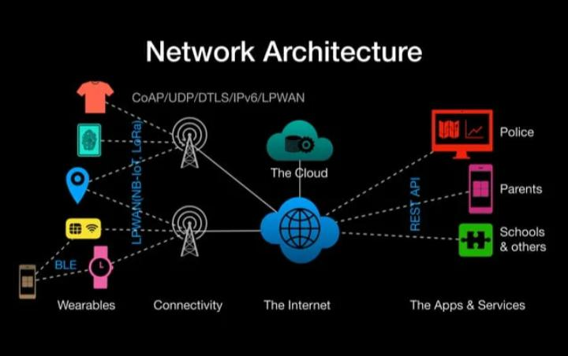

|  |  |
| --- | --- |
| Date | 04 November2022 |
| Team ID | PNT2022TMID45285 |
| Project Name | IOT based gadget for child safety monitoring and notification |
| Maximum Marks | 4 Marks |

**Technical Architecture:**

**Safety of a child in a large public event is a major concern for event organizers and parents. This paper addresses this important concern and proposes an architecture model of the IoT-enable smart child safety tracking digital system. This IoT-enabled digital system architecture integrates the Cloud, Mobile and GPS technology to precisely locate the geographical location of a child on an event map. The proposed architecture model describes the people, information, process, and technology architecture elements, and their relationships for the complex IoT-enable smart child safety tracking digital system. The proposed architecture model can be used as a reference or guide to assist in the safe architecture driven development of the various child tracking digital systems for different public events.**

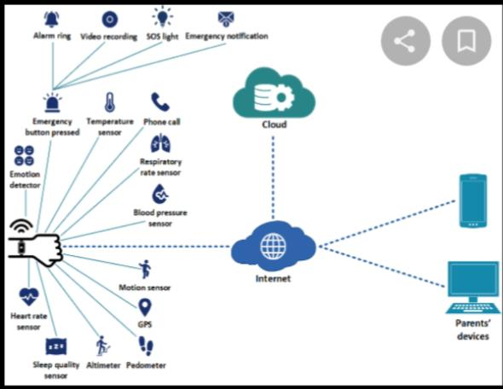

**Table-1 : Components & Technologies:**

|  |  |  |  |
| --- | --- | --- | --- |
| **S.No** | **Component** | **Description** | **Technology** |
|  | User Interface | How user interacts with application e.g.  Web UI, Mobile App, Chatbot etc. | HTML, CSS, JavaScript / Angular Js / React Js etc. |
|  | Application Logic-1 | Logic for a process in the application | Java / Python |
|  | Application Logic-2 | Logic for a process in the application | IBM Watson STT service |
|  | Application Logic-3 | Logic for a process in the application | IBM Watson Assistant |
|  | Database | Data Type, Configurations etc. | MySQL, NoSQL, etc. |
|  | Cloud Database | Database Service on Cloud | IBM DB2, IBM Cloudant etc. |
|  | File Storage | File storage requirements | IBM Block Storage or Other Storage Service or Local Filesystem |
|  | External API-1 | Purpose of External API used in the application | IBM Weather API, etc. |
|  | External API-2 | Purpose of External API used in the application | Aadhar API, etc. |
|  | Machine Learning Model | Purpose of Machine Learning Model | Object Recognition Model, etc. |
|  | Infrastructure (Server / Cloud) | Application Deployment on Local System / Cloud  Local Server Configuration:  Cloud Server Configuration : | Local, Cloud Foundry, Kubernetes, etc. |

**Table-2: Application Characteristics:**

| **S.No** | **Characteristics** | **Description** | **Technology** |
| --- | --- | --- | --- |
|  | Open-Source Frameworks | List the open-source frameworks used | Technology of Opensource framework |
|  | Security Implementations | List all the security / access controls implemented, use of firewalls etc. | e.g. SHA-256, Encryptions, IAM Controls, OWASP etc. |
|  | Scalable Architecture | Justify the scalability of architecture (3 – tier, Micro-services) | Technology used |
|  | Availability | Justify the availability of application (e.g. use of load balancers, distributed servers etc.) | Technology used |
|  | Performance | Design consideration for the performance of the application (number of requests per sec, use of Cache, use of CDN’s) etc. | Technology used |

**Children that will serve the purpose of alerts and way of**

**Communicating with secure channels and it update the**

**Current location through IOT. Safety device with wearable’s**

**Which help track the daily activity of children and also help**

**Find the child using Wi-Fi and Bluetooth services present on**

**The device. The child sends location coordinate by using**

**Sensor updates to the server and the updates saved in the**

**Database on the server. An ATmega328p micro-controller**

**Controls the system architecture of the wearable with an**

**Arduino boot-loader.**

**The system architecture of the wearable is based**

**And controlled by an ATmega328p micro-controller with an**

**Arduino UNO boot-loader.**

